**Unit 12 Life is full of the unexpected.**

**Section B3 (3a-Self check)**

**【学习目标】**

1. 掌握本单元基础知识， 掌握过去完成时的结构和用法。

2. 能够根据所学知识进行写作，提高写作能力。

3. 注意人们对所持文化认同感和对玩笑容忍度的差异， 愚弄他人时应持审慎及得当的态度。

**【重点和难点】**

【学习重点】

过去完成时的用法。

【学习难点】

过去完成时的用法，培养学生的写作及语言综合运用能力。

**【课前预习】**

**一、用括内所给单词的适当形式填空。**

1. He dreamed of being a police ___________ (office).

2. The ____________ (discover) of oil in this area is exciting.

3. His daughter got _____________ (marry) last month.

4. Many people like movies with a happy ____________ (end).

5. Mark is an honest boy. I think his words are ____________ (believe).

**二、根据汉语提示完成英语句子，每空一词。**

1. 我还没来得及和其他人一起出去看看发生了什么事情，第一架飞机已经撞上了我所在的办公大楼。

Before I could join the others outside to see __________ ___________ __________ _________, the first plane _________ already _________ my office building.

2. 这是我一年里度过的第一个假期，并且现在我还错过了我的飞机，多么倒霉

啊！

This is the first holiday I’ve ________ in a year, and now I’ve ________ my plane. _______ ________ ________!

3. 我的坏运气出乎意料地变成了一件好事。

My bad luck had _________ _________ _________ a good thing.

**【合作探究】**

探究一、知识积累

1. 翻译下列短语学科网(www.zxxk.com)--教育资源门户，提供试卷、教案、课件、论文、素材及各类教学资源下载，还有大量而丰富的教学相关资讯！：

1) 一生中最不幸的一天 ____________

2) 向西行驶 _____________

3) 在路中间 ______________

4) 调头 ______________

5) 有一个出乎意料的发现 ______________

6) 取消计划 _____________

7) 上交作学科网(www.zxxk.com)--教育资源门户，提供试卷、教案、课件、论文、素材及各类教学资源下载，还有大量而丰富的教学相关资讯！业 _____________

2. 完成句子。

1) 当我正向西走时，我看到一辆巨型卡车在路中间。

As I ______ ______ ______, I saw a huge truck in the middle of the road.

2) 我是如此高兴以致取消了去市场的计划。

I am so glad that I ______ ______ ______ ______ go to the market.

3) 每回她试着和她丈夫争辩，她总是以流泪结束。

Every time she tried to argue with her husband, she ______ ______ crying her

eyes out.

探究二、写作常用句型

1. my lucky/unlucky day

2. I will always remember the date…我将总是记得这个日子……

3. This was the luckiest学科网(www.zxxk.com)--教育资源门户，提供试卷、教案、课件、论文、素材及各类教学资源下载，还有大量而丰富的教学相关资讯！ /unluckiest day of my life…

这是我一生中最幸运或最不幸运的一天……

4. When I woke up that morning…当我早上醒来时……

5. Later that day，…后来那天……

6. I couldn't believe…我简直难以相信……

7. Then/After that，…然后/在那以后……

8. Finally，…最终……

9. I think…我认为……

10. What a lucky/an unlucky day! 多么幸运/倒霉的一天啊！

探究三、单元写作小专题

【单元写作目标】

本单元的话题是“unexpected events(难以预料的事情)”，与此相关的写作通常是根据图画或文字提示，描述一次难忘的经历。这类作文通常按记叙文来写，写作时，要详细叙述事情发生的经过和结果，并适当抒发自己的感情。

话题范文剖析

假如你是林凯，请你根据下表中的内容提示，合理发挥想象写一篇100词左右的短文，描述一下发生在你身上的这些意外事件。

|  |  |
| --- | --- |
| **Something unexpected** | **Result** |
| 父母很早出门上班 | 睡过了头 |
| 到公交站时车已经开走 | 上学迟到 |
| 忘带作业 | 回家取的路上被摩托车撞伤 |

◆◆审题指导

1.文体：记叙文

2.时态：一般过去时和过去完成时

3.注意事项：本文应按照时间顺序来写，注意恰当使用连接词，使文章前后连贯。

◆◆思路点拨

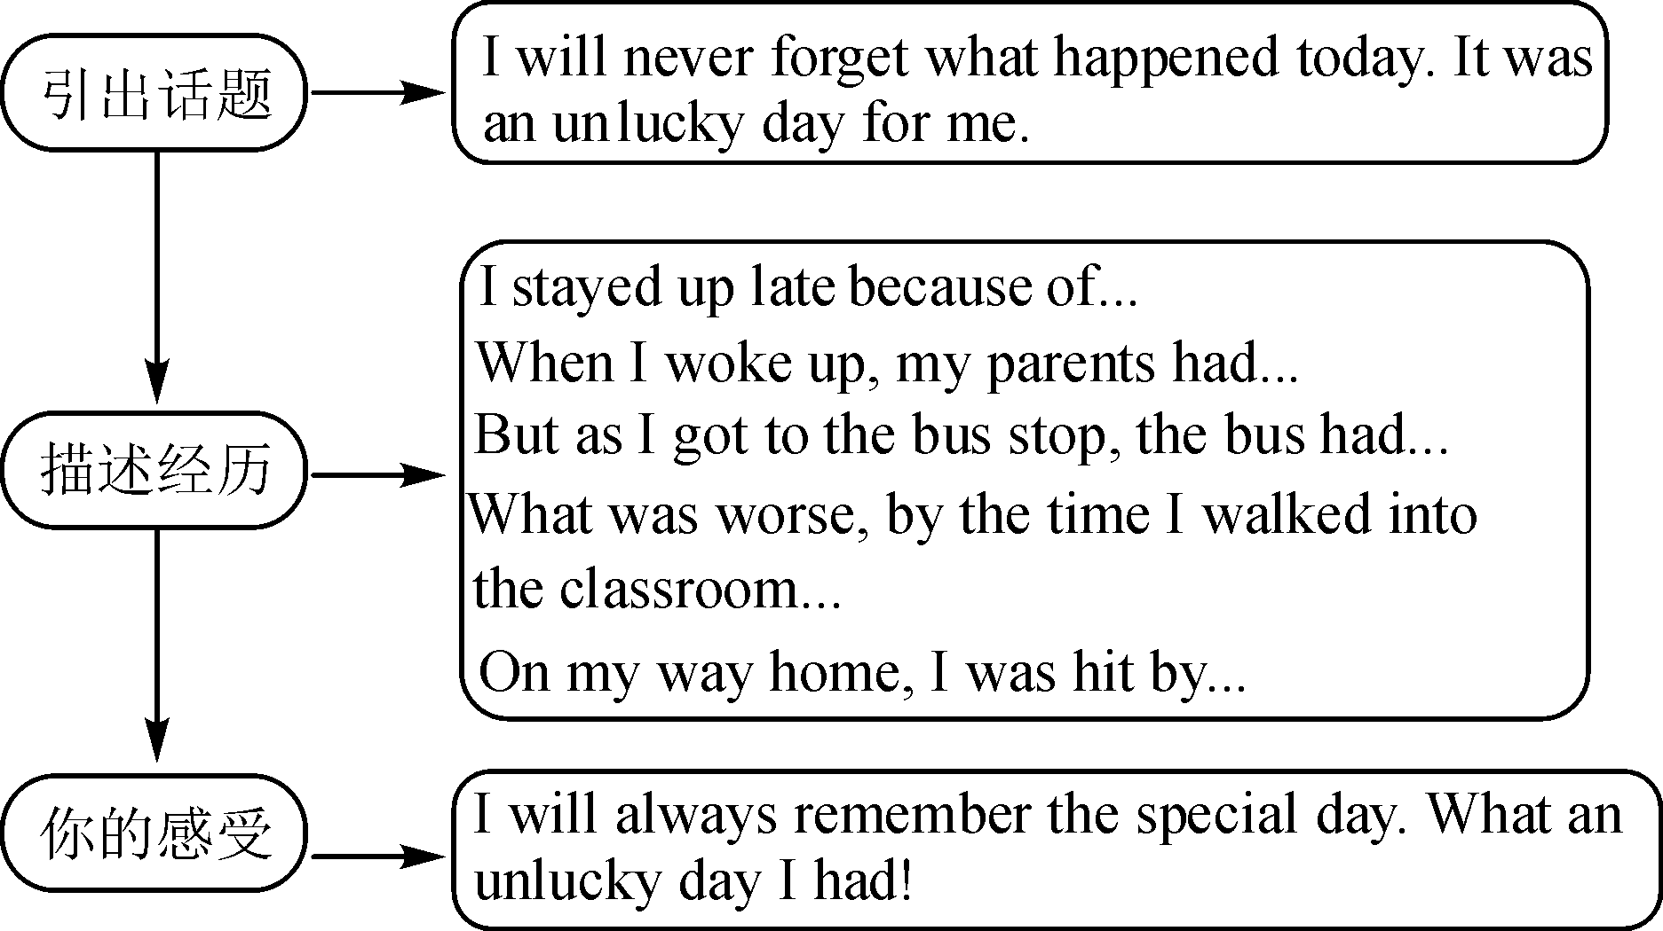

◆◆范文欣赏

I will never forget what happened today. It was an unlucky day for me.

I **stayed up** late last night because of an exciting soccer match. So I didn't hear the alarm **go off** this morning. When I **woke up**, my parents had left for work. I overslept. I didn't have breakfast and rushed to the bus stop. But as I got to the bus stop, the bus had already left. As a result, I was late for school. **What was worse**, **by the time** I walked into the classroom, I found I had forgotten to bring my homework. I had to ask the teacher to allow me to fetch it. **Unluckily**, on my way home, I was hit by a motor bike. I had a great pain in my arms and had to go to the hospital.

I will always remember the special day. **What an unlucky day I had today!**

单元写作练笔

每个人都有自己幸运和不幸的时候。假如你叫蔡军，请你根据以下提示及要求写一则日记，记录自己糟糕的一天。

提示：

1. 昨天因为熬夜而睡过了头；

2. 未赶上公共汽车导致上学迟到；

3. 上课注意力不集中未能回答上来英语老师的问题；

4.……

要求：

1. 语句通顺，语意连贯；

2. 包含所有提示内容，可适当发挥；

3. 80—100词(日记格式已给出，不计入总词数)。

Monday, November 26th，2019

Sunny

_______________________________________________________________________________________________________________________________________________________________________________________________________________

**【课时小结】**

重点词组

1. the unluckiest day of my life 一生中最不幸的一天

2. head west 向西行驶

3. in the middle of the road 在路中间

4. turn around 调头

5. make an unexpected discovery 有一个出乎意料的发现

6. cancel the plan 取消计划

7. hand in homework 上交作业

重点句式

1. What a lucky day!

2. As I was heading west, I saw a huge truck in the middle of the road.

3. However, I missed the road that led to the mall.

4. I went inside and the lady, who was the owner, served me the most delicious bowl of chicken noodles ever.

**【达标检测】**

**一、用所给单词的适当形式填空。**

1. Don’t give up. Our life is full of the __________(expect).

2.  He doesn’t ________(believe) Tom’s words. So he asked his teacher in ______ (belief).

3.  Look at the __________ (burn) house. How terrible!

4. How __________(fool) the boy is!

5. Tom felt ___________ (embarrass) when he couldn’t answer the easy questions.

**二、句型转换。**

1. They began to climb the mountain after they had bought all the food.（否定句）

2.  Lucy had already completed the project when I arrived.（改为一般疑问句）

3. We had had the toys for ten years before we gave them to the child. （对划线部分提问）

 4. His English is so bad that I can’t understand it. （同义句）

His English is  _______ for me  understand.

= His English isn’t _______ _______ for me ________ understand.

**【自我评价】**

1. 本课我学会了什么？

________________________________________________________

2. 通过本课的学习，我还有哪些疑问？

___________________________________________________

参考答案：

**【课前预习】**

**一**1. officer 2. discovery 3. married 4. ending 5. believable

二1. what was going on; had; hit 2. taken; missed; What bad luck

3. unexpectedly turned into

探究一

1) the unluckiest day of my life 2) head west 3) in the middle of the road

4) turn around 5) make an unexpected discovery 6) canceled my plan

7) hand in homework

2. 1) was heading west 2) cancelled my plan to 3) ended up

探究三

Monday, November 26th，2019 Sunny

I overslept this morning because I **stayed up late** last night. **By the time** I woke up, my sister had gone into the bathroom. After she came out, I washed my face and brushed my teeth **as soon as** possible. Then I left home and **ran towards** the bus stop. **Unluckily**, when I got to the stop, the bus had gone. **As a result**, I **was late for** school. The first class was English. I was so sleepy that I couldn't **pay attention** in class. My English teacher asked me a question but I even didn't know what she was asking me. It made me **feel embarrassed** and my English teacher was angry. She asked me to copy the text for three times!

What a bad day I had today!

【达标检测】

**一** 1. unexpected 2.  believe; disbelief 3.  burning 4. foolish 5. embarrassed

**二** 1. They didn’t begin to climb the mountain after they had bought all the food.

 2. Had Lucy completed the project when you arrived?

3. How long had you had the toys before you gave them to the child？

  4. too bad, to; good enough, to